EN.520.680 HW2

1. For the question 1, there’s a main program and a function in the submit file. The function one is the STFT program I write, just check that.
2. In the process of short-time Fourier transformation, the length of the window determines the time resolution and frequency resolution of the spectrogram. The longer the window length, the longer the intercepted signal, the higher the frequency resolution, and the worse the time resolution. In STFT, time resolution and frequency resolution cannot have both, and should be chosen according to specific needs. In other words, the narrow window has high time resolution and low frequency resolution, and the wide window has low time resolution and high frequency resolution. For time-varying non-stationary signals, high frequencies fit into a small window, and low frequencies fit into a large window. In question 2, I make some test, probably should take the frequency between 10kHz and 20kHz.
3. I set the frequency, window and overlap as the homework asked. Then I changed the window length and get the result below.

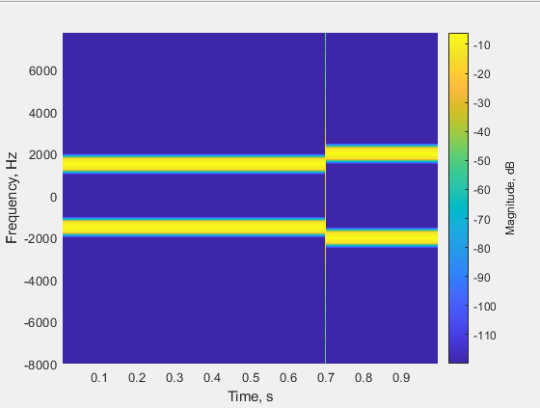

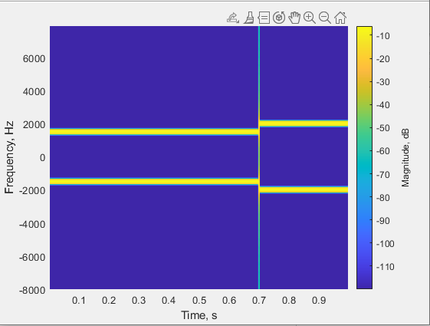

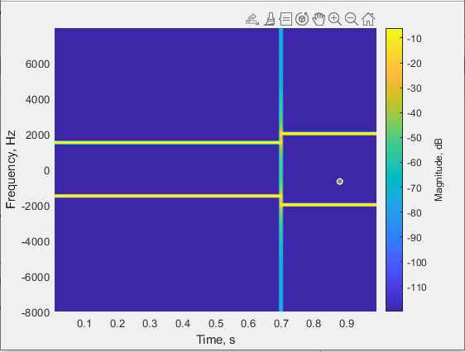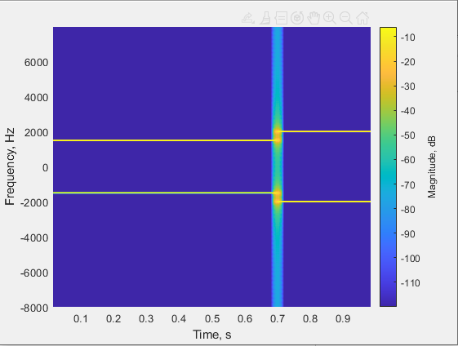

After my observation, when the window length is too narrow and the signal in the window is too short, which will lead to inaccurate frequency analysis and poor frequency resolution. The specific performance is that the yellow horizontal line becomes wider and more blurred. If the window length is too wide, the time domain is not fine enough, and the time resolution is low. The specific performance is that the light blue vertical line is getting wider and more blurred. Among them, the vertical line represents the high-frequency interference component caused by the sudden change at the junction. The time resolution of STFT depends on the slip width H, while the frequency resolution depends on F/H. Obviously, an increase in one must necessarily mean a decrease in the other. This is the so-called uncertainty principle. After I checked some information on the Internet, I found that the fixed window size is too rigid. For low-frequency signals, it may not cover even one cycle; for high-frequency signals, it may cover too many cycles and cannot reflect signal changes. At this time, people usually use wavelet transform to solve this dilemma.